Index
- Log in........................................................................2
- Devices.....................................................................4
- Zoom in....................................................................5
- Zoom Out.................................................................6
- Common...................................................................7
- Satellite.....................................................................8
- Terrain......................................................................9
- Hybrid.......................................................................10
- Log out............................................................... 11

₁
1. Log in Screen:
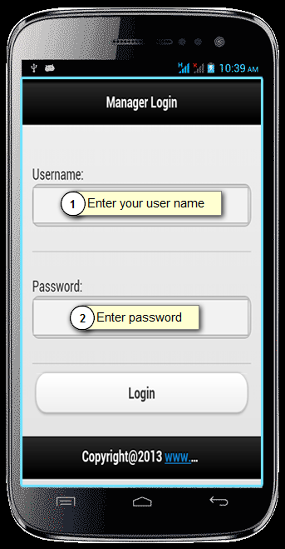
- This is log in Screen of the mobile web.
- You want to log in this mobile web so enter username or pass word.
- Enter the username and password then after the press log in button and visit our mobile web.
2

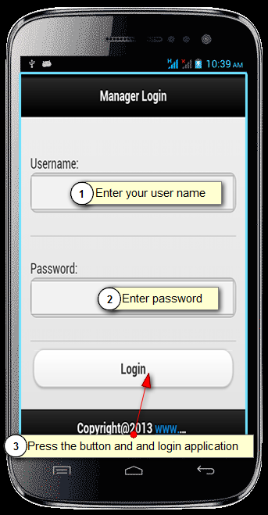

- This is log in screen.
- Enter username or password then after press log in button.

3

2. Devices:
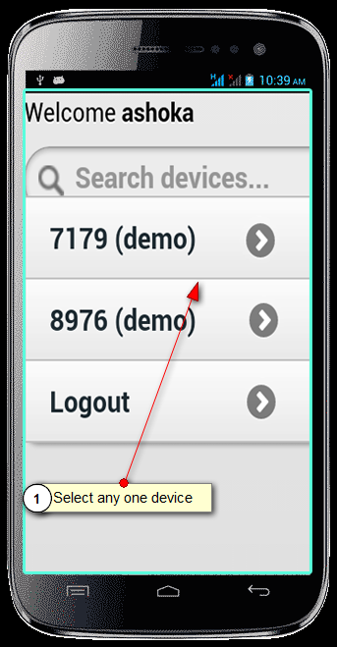

- This is devices list screen.
- Select any one devices to track location.
4
3. Zoom in :
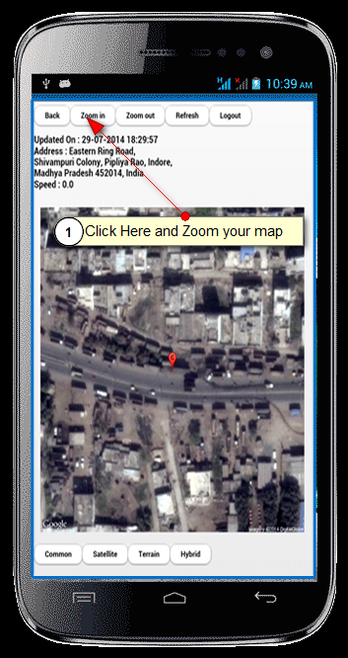

- This is device location on map views.
- Click to zoom in button to zoom map view location.

5
4. Zoom out :
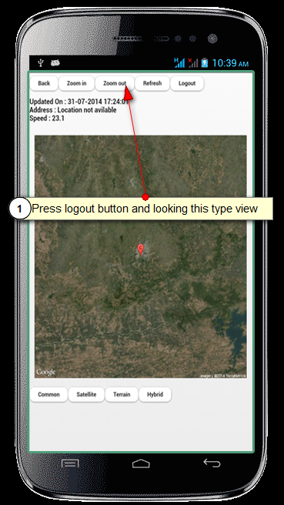
- This is device location on map views.
- Click to zoom out to zoom out map view location.

6
5. Common :
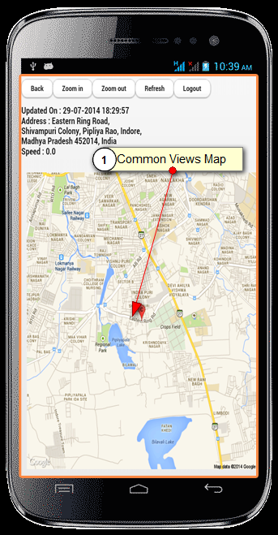

- This common type map view.

7

6. satellite :
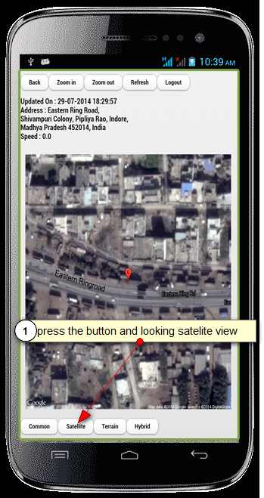
- This is satellite mode map view.
- Press the button and looking satellite view.
8
7. Terrain :
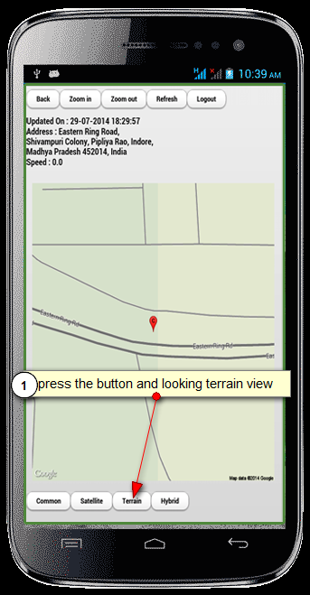
- This is terrain type map view.

9
8. Hybrid :
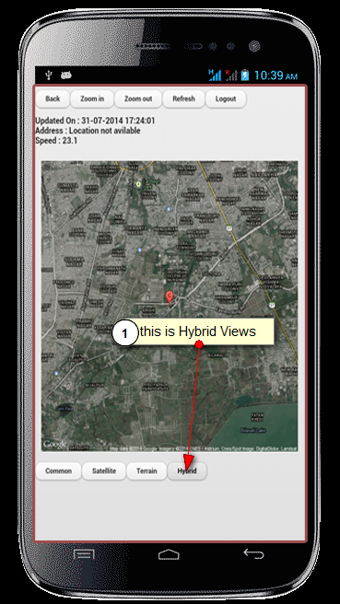
- This is hybrid type map view.
- You looking this type view so press the hybrid button.

10

- log out :
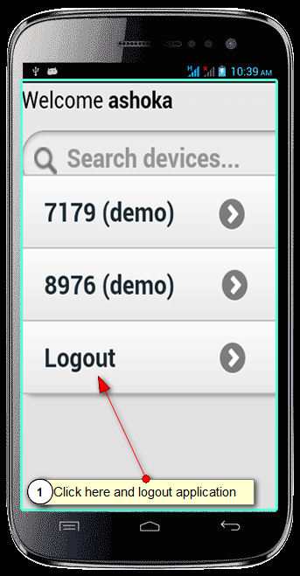
- If you want to logout this mobile web so press log out button.

11

